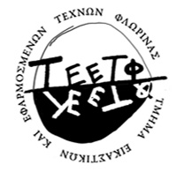 | UNIVERSITY OF WESTERN MACEDONIA  SCHOOL OF FINE ARTS | 
Department of Fine and Applied Arts

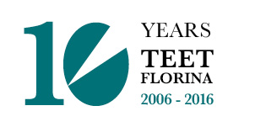
International Conference
For a School of Visual Arts in the 21st Century
Florina, Greece, 12-14 May 2017
The Department of Fine and Applied Arts of the University of Western Macedonia is organizing the conference "For a School of Visual Arts in the 21st century" because of its ten-year operation since its foundation. The conference will be held in Florina, Greece, from 12th to 14th May 2017.
The mission of a Visual Arts Institution in Tertiary Education is triple: artistic, educational and social. It constitutes an educational body and is an active cultural and social place where future artists are taught how to form the visual image and their artistic identities.
The international conference "For a School of Visual Arts in the 21st century” aims to explore the triple function of a contemporary Fine Arts Institution and its innovative educational approaches through which modern tertiary education can become a creative place of artistic and social reality.

Main Themes
- School of Visual Arts: the relation with society and the broader cultural framework.
- The history of curricula and methods of artistic teaching (Traditional teaching methods: the contemporary framework. Hybrid expressions of art in artistic teaching. Relational/group practices used as a model of developing artistic educational processes).
- School of Visual Arts and Art World.
- School of Visual Arts and economy: relations with the small and large industrial production, cultural tourism etc. Relations with the art market.
- Graduate students of Fine Arts Faculties and professional career.
The Scientific Committee of the conference is inviting the teaching staff of Visual Arts and relevant faculties, artists, scholars to submit proposals for individual papers (15-20 minutes long) by the 10th of March 2017 that should be pertinent to the above themes. For each paper presentation an abstract of approximately 300 words is required.
Official languages of the conference are Greek and English.
The abstract and the form attached will be submitted online sinedrioteet@uowm.gr (fill in the fields of the form that refer to the personal information, the presentation title, the main theme, and the short curriculum vitae).
Important dates
10 March 2017: Abstract submission
30 March 2017: Author Notification
12-14 May 2017: Conference
The Scientific Committee
Areti Adamopoulou, Associate Professor, School of Fine Arts, Department of Fine Arts and Sciences of Art, University of Ioannina
Zoe Godosi, Assistant Professor, School of Fine Arts, Department of Fine and Applied Arts, University of Western Macedonia
Yannis Ziogas, President, Assistant Professor, School of Fine Arts, Department of Fine and Applied Arts, University of Western Macedonia
Thanasis Moutsopoulos, Associate Professor, School of Architecture, Technical University of Crete
Xenis Sahinis, Professor, Dean of the School of Fine and Applied Arts, Aristotle University of Thessaloniki
Marios Spiliopoulos, Professor, Department of Fine Arts, Athens School of Fine Arts
You can find more information on the website:
http://10yearsteet.eetf.uowm.gr/

